Egypt, Arab Rep.

## Respect for rule of law (ROL) data

The data set shows the data on the respect of the rule of law for the country.

## # A tibble: 19 x 5  
## country iso3c date ruleOfLaw ruleOfLawCategory4   
## <chr> <chr> <dbl> <dbl> <chr>   
## 1 Egypt, Arab Rep. EGY 1996 0.00126 ROL moderately respected   
## 2 Egypt, Arab Rep. EGY 1998 -0.0405 ROL moderately disrespected  
## 3 Egypt, Arab Rep. EGY 2000 -0.0108 ROL moderately disrespected  
## 4 Egypt, Arab Rep. EGY 2002 0.0123 ROL moderately respected   
## 5 Egypt, Arab Rep. EGY 2003 0.0214 ROL moderately respected   
## 6 Egypt, Arab Rep. EGY 2004 0.0195 ROL moderately respected   
## 7 Egypt, Arab Rep. EGY 2005 -0.0242 ROL moderately disrespected  
## 8 Egypt, Arab Rep. EGY 2006 -0.258 ROL moderately disrespected  
## 9 Egypt, Arab Rep. EGY 2007 -0.230 ROL moderately disrespected  
## 10 Egypt, Arab Rep. EGY 2008 -0.129 ROL moderately disrespected  
## 11 Egypt, Arab Rep. EGY 2009 -0.105 ROL moderately disrespected  
## 12 Egypt, Arab Rep. EGY 2010 -0.179 ROL moderately disrespected  
## 13 Egypt, Arab Rep. EGY 2011 -0.452 ROL moderately disrespected  
## 14 Egypt, Arab Rep. EGY 2012 -0.472 ROL moderately disrespected  
## 15 Egypt, Arab Rep. EGY 2013 -0.633 ROL moderately disrespected  
## 16 Egypt, Arab Rep. EGY 2014 -0.663 ROL moderately disrespected  
## 17 Egypt, Arab Rep. EGY 2015 -0.594 ROL moderately disrespected  
## 18 Egypt, Arab Rep. EGY 2016 -0.508 ROL moderately disrespected  
## 19 Egypt, Arab Rep. EGY 2017 -0.535 ROL moderately disrespected

## Respect for rule of law (ROL) trend

The plot shows the trend of the respect for the rule of law for the country.

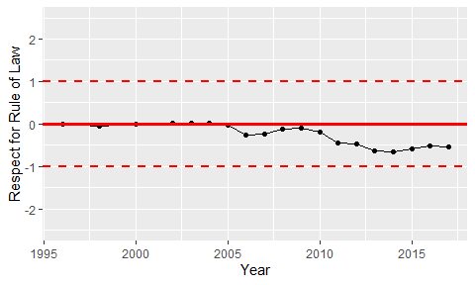

Trend of the Respect for the Rule of Law